
Technical Bulletin
i14 Circulation Pump Change

August 19, 2026
Version 1.0

Issue

Some i14 circulation pumps can produce a high-pitched whine. The noise is caused by air becoming trapped inside the pump; without sufficient turbulence to displace it, the air can remain trapped indefinitely. This condition is only a nuisance and does not result in functional failure or impact unit performance.

Affected Units

Any unit produced prior to May 1, 2026, could be affected.

The unit serial number contains the date code in the format Z10597-YYMMDD-00XXX.

Units with date code 260501 or higher are unaffected.

Pump Identification
Model | Component | Part Number | Identifying Mark | Date Code | Action Required
i14 | Circulation pump (original) | 41-2499-0 | No sticker | Prior to 260501 | Replace at next service
i14 | Circulation pump (updated) | 11-4341-0 | Green dot sticker near wires | 260501 or higher | None

Solution
Part Needed | Part Number | Contact | Phone | Menu Option
Circulation pump (updated) | 11-4341-0 | Quench Tech Support | 855.558.9796 | Option 3

The circulation pump has undergone a design change that prevents the condition from arising. Any dealer can request a replacement pump using the contact details above.

Technicians are recommended to replace the pump at the next service of an affected unit to avoid future noise complaints. Proactive field visits are not required.

Replacement Procedure
Replacing the pump requires some time, as it entails removing body panels and temporarily removing the cold tank to access the pump.
A video demonstrating how to prepare the unit and access the pump for replacement is available on the Tech portal: https://techportal.waterlogicdealers.com/i14-videos/
Identifying the New Pump
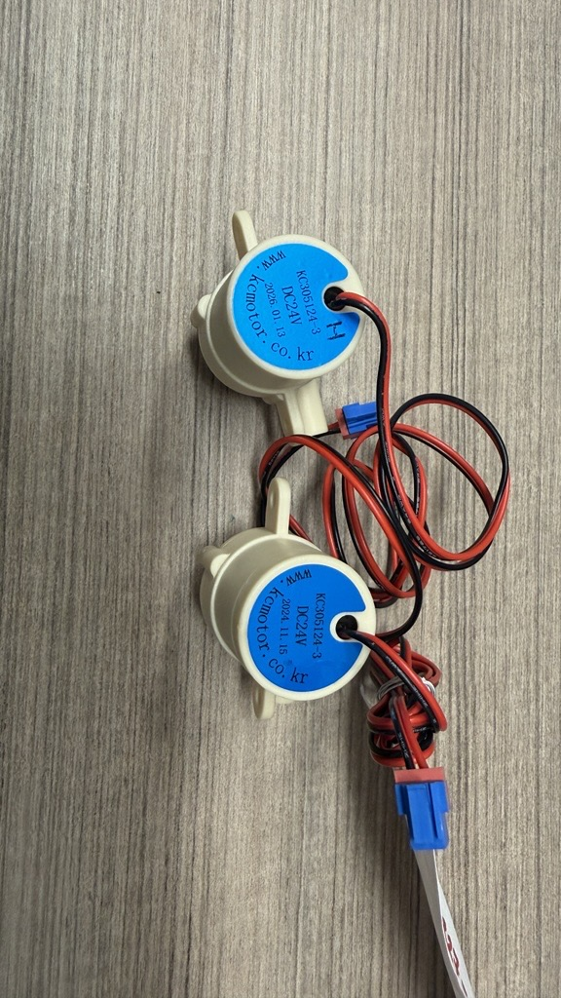
Updated pumps carry a green dot sticker close to the wires. The photo below shows an updated pump (Left) alongside the existing pump (Right); the molded date code is visible on each label.

Updated pump (top, date code 2026.01.13) and existing pump (bottom, date code 2024.11.15).

Revision History
Rev | Date | Description | Author
1.0 | August 19, 2026 | Origination of document. | Chance McIntyre

